WALMART
Operational Analytics Project
NIL PICKS IMPACT ON
OPD FULFILLMENT PERFORMANCE
Prepared by: Angel Molina | Digital Personal Shopper, OPD Department
Store: Walmart Store #1837
Address: 9451 FM 1960 Bypass West, Humble, TX 77338
Observation Period: April 25 to May 29, 2026
Data Sources: MyWalmart App
Tools: Microsoft Excel • Power BI
For Portfolio Use Only

Executive Summary
This report examines how Not-In-Location (NIL) picks affect fulfillment performance in the Online Pickup & Delivery (OPD) department at Walmart. It was written by a Digital Personal Shopper with firsthand experience in the department, using five weeks of directly observed operational data from April 25 to May 29, 2026.

NIL picks occur when the GIF app directs a picker to a shelf location and the item is not there despite being shown as in stock. Each event forces a substitution or cancellation, eroding First Time Pick (FTP) rates and worsening the customer experience. Data was drawn from the work app used by associates named GIP app (Global Integrated Fulfillment), then structured in Excel and visualized in Power BI.

Key findings:

- Food/Consumables generated 66% of all NIL picks (605 of 919 total events), surpassing by far every other department.
- Out Scans exceeded 13,250 across 15 snapshots. Hardlines, Home, and Food/Consumables showed the highest sustained counts, signaling latent inventory inaccuracy beyond NIL events.
- GM, Grocery, and Frozen/Dairy/Deli received 89% of all inbound freight. Delays working this freight to the shelf are a direct upstream driver of NIL events.
- Freight completion averaged 74.5%, ranging from 50% to 100%. Lower completion days correlated with higher NIL counts in the same shift.
- FTP averaged 94.0%, never reaching the 95%+ target on any observation date.

Recommendations focus on daily NIL Picks in Food/Consumables, structured Out Scan monitoring, and aligning freight completion with OPD pick schedules.

1. Business Problem
What Is a NIL Pick?
A NIL pick is recorded when a Digital Personal Shopper arrives at an assigned shelf location for an item and it is absent, even though inventory shows it as in stock. This differs from a standard out of stock, which reflects an expected inventory depletion managed in advance. A NIL is a live discrepancy between system data and shelf reality, discovered only during a pickwalk.

In OPD, pickers use the GIF app to navigate optimized pick paths through the store. When GIF sends a picker to a location with no item, the picker must flag the NIL and initiate a substitution or removal, which adds time and creates a potential negative order outcome.

Why NIL Picks Matter
NIL picks affect performance at every level simultaneously. For the picker, they add unproductive time and create pressure since FTP is a stat tracked closely by store leadership. For the department, repeated NILs in the same locations point to inventory accuracy failures that picking effort alone cannot resolve. For the customer, items that cannot be substituted are dropped from the order, directly impacting satisfaction and repeat orders.

Operational Impacts
- Reduced FTP: NIL picks lower the percentage of items located on the first attempt, the store's primary OPD efficiency metric.
- Inventory Accuracy Erosion: High NIL rates signal that system on-hand counts do not match physical stock, compounding replenishment decisions.
- Customer Experience: Items dropped from orders increase complaint rates and reduce trust in curbside and delivery services.
- Associate Pressure: Pressure put into the picker to not Nil pick an item, and only do so if the item is really not in the place, which sometimes forgets about how some items are located in multiple locations but not all of them are saved in the system.

2. Operational Environment
Walmart Digital Fulfillment
Walmart's OPD department (Online, Pickup and Delivery), also referred to as OGP (Online Grocery Pickup), covers curbside pickup and same day delivery. Digital Personal Shoppers fulfill orders using the GIF app, which routes pickers through the store using live inventory data. As digital order volume has grown, OPD has become a critical revenue channel requiring tight coordination between pickers, stocking, and receiving teams.

Receiving & Inventory
Freight arrives from distribution centers and DSD vendors and is classified into four statuses: Planned, On the Way, Arrived, and Complete. The key risk for OPD is freight that has been received and logged as in stock but not yet worked to the shelf — creating phantom availability that generates NIL picks when pickers arrive at empty locations.

Inventory accuracy is tracked via SKU vs. Book % and Inventory vs. Sales %. During the observation period, SKU vs. Book deteriorated from -7.5% in late April to -13.1% by mid-May, a widening accuracy gap that directly coincides with elevated NIL rates in the latter half of the study. Shrink ran at -$1.3M actual vs. a -$1.5M plan, meaning the store was favorable to shrink budget, even though the worsening SKU accuracy suggests inventory displacement beyond traditional theft was contributing to the NIL environment.

3. Data Collection & Methodology
All data was collected between April 25 and May 29, 2026. Observations show 11 unique dates at various times of day, yielding 15 KPI snapshots, 90+ freight records, and three complete NIL/Out Scan breakdowns by department.

Three types of data found in MyWalmart App: the KPI dashboard (Sales, FTP %, NIL Picks, Out Scans, GIF metrics), the freight receiving system (trailer arrivals, pallet/case counts, completion rates), and the NIL tracker (NIL and Out Scan counts by department). Data was structured in Excel and visualized in Power BI.

Metric | Source | Unit | Relevance
NIL Picks | MyWalmart App | Count | Primary outcome variable
FTP % | MyWalmart App | Percentage | First-attempt pick efficiency
Out Scans | MyWalmart App | Count | Inventory inaccuracy indicator
Sales ($k) | MyWalmart App | $k (thousands) | Order volume context
Freight Completion % | MyWalmart App | Percentage | Replenishment execution proxy
Cases by Department | MyWalmart App | Case count | Freight workload by area
SKU vs. Book % | MyWalmart App | Percentage | Inventory accuracy measure
NIL Picks by Dept. | MyWalmart App | Count | Pinpoints high-risk departments

4. Power BI Dashboard
A Power BI dashboard was built to enable interactive visual analysis of the dataset. It is organized across five pages, KPI Overview, NIL & Inventory Analysis, Trends, Freight Operations, and Freight Completion with cross-filter slicers for date range, department, and freight status

The dashboard surfaces five key visuals: KPI scorecards for FTP %, total NIL Picks, total Out Scans, and average Freight Completion; NIL Picks and Out Scans bar charts by department; a Sales vs. NIL Picks combo chart; an FTP % trend line with a 95% target reference; and a Freight Completion trend line. Together these visuals make every finding in this report immediately visible without navigating a multi-sheet workbook.
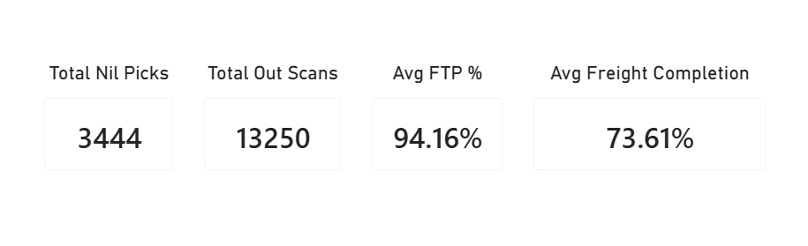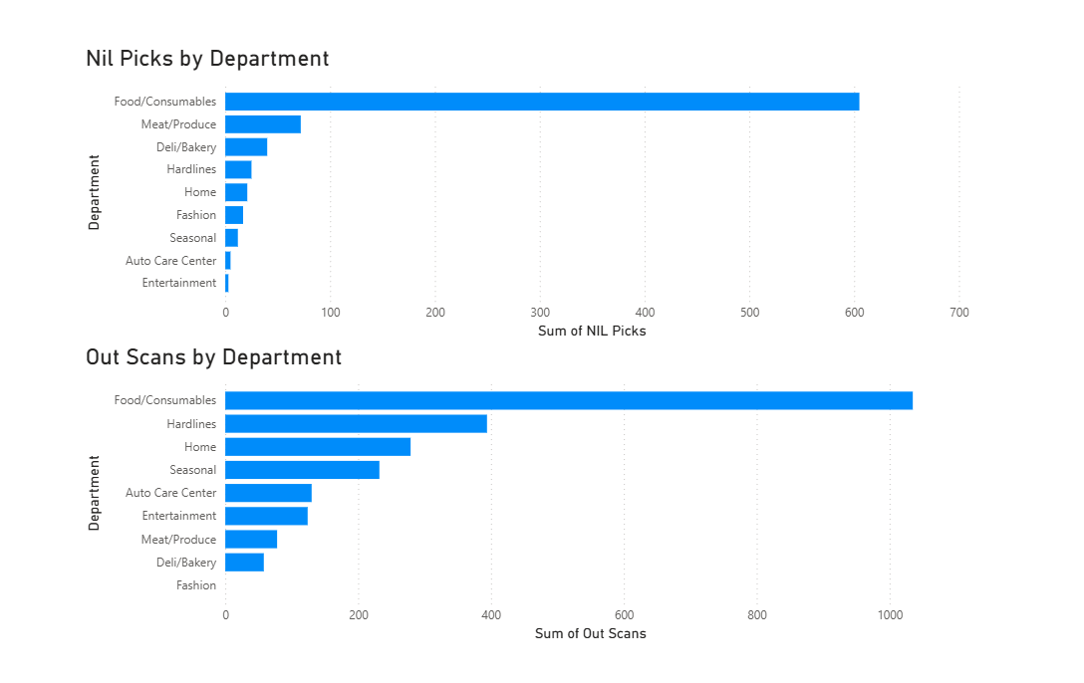

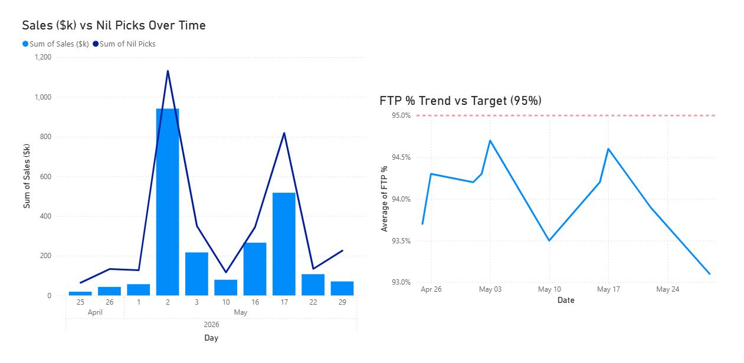
5. Key Findings
Finding 1 — Food/Consumables Dominates NIL Activity
Key Stat
Food/Consumables: 605 NIL picks out of 919 total (66%) across May 17, 22, and 29.

The concentration was consistent across all three observation dates. On May 17 the department logged 321 NIL picks — more than six times the next-highest department (Meat/Produce at 43). On May 22 the count was 89, and on May 29 it was 195. The May 17 spike followed a freight completion rate of 62.5%, supporting the pattern that incomplete freight in this area directly worsens same-shift NIL rates.

Finding 2 — Out Scans Signal Latent Inventory Risk
Key Stat
Food/Consumables averaged 345 Out Scans per observation. Hardlines averaged 131, Home averaged 93.

Out Scans reflect items found but not where the system expects them — a persistent location discrepancy rather than a missing item. Hardlines and Home showed elevated Out Scans despite relatively low NIL counts, indicating latent inaccuracy that has not yet converted into NIL events but could worsen. Fashion was the only department with zero Out Scans across all dates.

Finding 3 — Freight Workload Concentrates in High-NIL Areas
Key Stat
GM: 39,919 cases. Grocery: 28,737. Frozen/Dairy/Deli: 22,280. Together: 89% of all inbound freight.

The departments with the heaviest freight loads are the same ones most sensitive to NIL risk. Grocery and Frozen/Dairy/Deli form the replenishment backbone of Food/Consumables picking. When over 50,000 cases need continuous processing and execution lags, the system logs product as available before it is physically shelved — creating the phantom availability that generates NIL events.
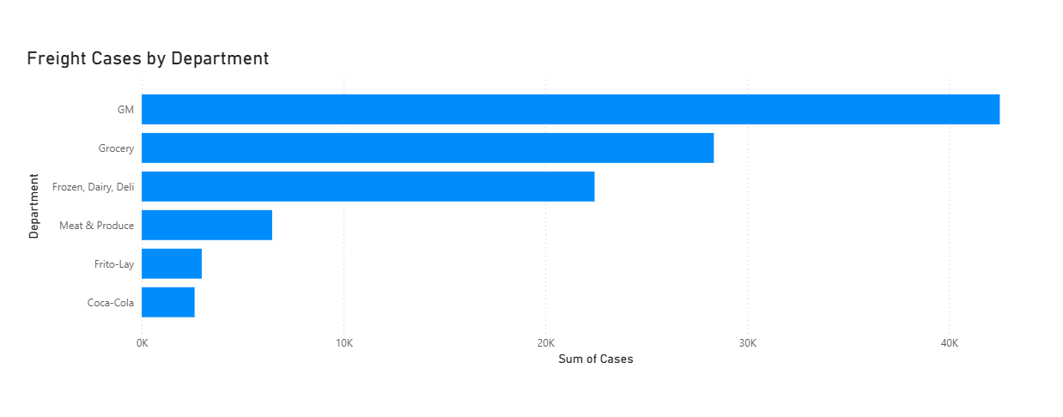
Finding 4 — Freight Completion Correlates with NIL Performance
Key Stat
Freight completion ranged from 50% (Apr 25) to 100% (May 2), averaging 74.5% across all observation dates.

On April 25 at 50% completion, 64 NIL picks were recorded — the lowest in the dataset, though morning order volume was also low. On May 17, 62.5% completion at 1:20 PM was followed by 440 NIL picks by 9:40 PM. The relationship is directional rather than strictly causal given observation timing, but the pattern is consistent: lower mid-day completion correlates with higher NIL counts later in the same shift.

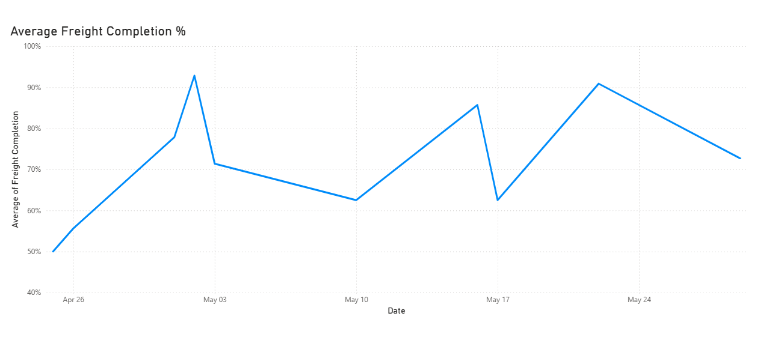
Finding 5 — FTP Trails Target Throughout the Period
Key Stat
FTP ranged from 93.1% to 94.7%, averaging 94.0% — below the 95%+ target on every single observation date.

First Time Pick % measures the share of items located and scanned successfully on the first attempt. It never reached 95% across 15 observations, with the metric declining further in the final week. FTP is ultimately a measure of whether the shelf matches the system — a picker cannot improve it through effort alone when items are not where GIF expects them. Reducing NIL picks through better inventory accuracy and freight execution is the most direct lever to close the gap.
6. Recommendations
1. Real Time Shelf Inventory Detection
The most persistent driver of NIL picks is the gap between what the system believes is on the shelf and what is physically there. Implementing smart shelf technology, such as sensors or weight based detection systems that update on hand counts in real time as product is removed would eliminate phantom availability at the source. Rather than discovering inventory discrepancies at the moment of picking, the system would reflect shelf reality continuously. This is an infrastructure investment that addresses the root cause and would have the most significant long-term impact on NIL reduction across all departments.
2. Targeted Stocker Deployment in High Nil Aisles
Stocking assignments are typically distributed by department, not by Nil picks. For example, rotating stockers into the specific aisles within Food/Consumables, Hardlines, and Home that are generating the highest NIL counts, even temporarily during high-volume periods, it would improve shelf accuracy exactly where it matters most. This is a low-cost and immediately actionable change.
3. Demand based Replenishment Prioritization
Not all products replenish at the same rate, but replenishment schedules do not always reflect that. Items in Food/Consumables that are frequently Nil picked should be flagged for more frequent replenishment cycles — essentially treating them the way perishables are treated, with daily attention rather than scheduled rotation. These items can be identified using existing NIL and Out Scan reports and adjust stocking frequency without requiring system changes.
4. Weather-Driven Demand Forecasting and Safety Stock Adjustments
In Texas, we are very used to sudden weather events such as storms, flash flood warnings, and freeze advisories which create demand spikes for essential items such as water, food, toilet paper and so much more. These spikes are not random; they are triggered by events that are publicly announced hours or days in advance. Despite this, replenishment systems seem to consistently fail to account for them, leaving high-demand items stocked out before the surge passes, and generating NIL picks precisely when OPD order volume is at its highest.
The recommendation is to establish a weather-triggered safety stock protocol so that designated high-risk of stockout items in Food/Consumables should have their reorder points temporarily elevated and replenishment orders accelerated.

7. Conclusion
This analysis confirmed that NIL picks are a traceable and measurable source of OPD inefficiency. Their root causes concentrate in specific departments, correlate with identifiable operational gaps, and follow patterns that can be monitored and act upon.

Food/Consumables requires the most immediate attention, its combination of high Nil picks volume, high Out Scans, and heavy freight throughput makes it both the largest source of FTP drag and the highest-leverage target for improvement. Across all departments, the relationship between freight completion and same-shift Nil rates points to replenishment execution as the upstream variable most worth controlling.

FTP averaging 94.0% consistently below the 95% target represents a gap that cannot be closed through picking effort alone. The recommendations in this report address that directly using processes already available within the store's operations. Future work could expand this analysis to the item and location level, and correlate FTP trends with customer satisfaction scores to quantify the full business cost of inventory inaccuracy.

